International Summer University WU – Testimonial (approx. 1 page)
Name of student: Tess Skoller

Home University: University of North Carolina-Chapel Hill, Kenan-Flagler Business School, MBA@UNC

How did you learn about the ISUWU and why did you choose to participate?
My university has a relationship with ISUWU, and it was one of the options for me to study internationally for a portion of my MBA. I chose to participate in this program after researching the university and getting a sense for the potential academic schedule I would have while studying here. I was so impressed by the care and detail ISUWU puts into the structure of this program for graduate students. The wealth of information available made it easy for me to get a sense of what studying at the WU would look like without having much prior knowledge about the university. My actual experience was above and beyond anything I could have expected when I was applying to the program.

How did participating in the ISUWU help you in terms of your personal / professional / academic development?
ISUWU helped me develop both academically and personally in a very short amount of time. With the accelerated nature of our classes, it required me to think quickly and make efficient decisions. We’re required to balance our academics with our social schedule and personal exploration of our temporary home city – but the entire ISUWU staff helped to ensure that we were setup for success in all elements of our lives during the program.

What can you tell us about the academic program and the lecturers? What was your impression?
Given my MBA program is entirely online, being able to interact with fellow graduate students and professors in person has been a welcome change. The professors and lecturers are very well seasoned in either industry or academic area of focus, which translated to our classes being substantial in lectures and assignments. Each of the lecturers understood we are working professionals in addition to graduate students, so they always found a way to connect how the class topic(s) pertain to our jobs and professions.

How did you like the social and cultural program? Did you have enough opportunities to make new contacts?
I was really impressed by the social and cultural events planned for our group. These events allowed me to not only to get to know Vienna but also provided an opportunity for me to connect with my fellow students outside of the classroom.

What was your personal highlight / your favorite memory about this program?
The moment from the program that I’ll always remember will be casually meeting the President of Austria, Alexander Van der Bellen, on the plaza outside of the Natural History Museum of Vienna. We were nearly at the end of our city walking tour when our guide mentioned the President was just a few steps away from our group, chatting with people walking through the plaza. Our guide decided to go over and ask the President if our group could take a picture with him, and he said yes! It was one of the highlights of the trip and we all appreciated how approachable the President was.
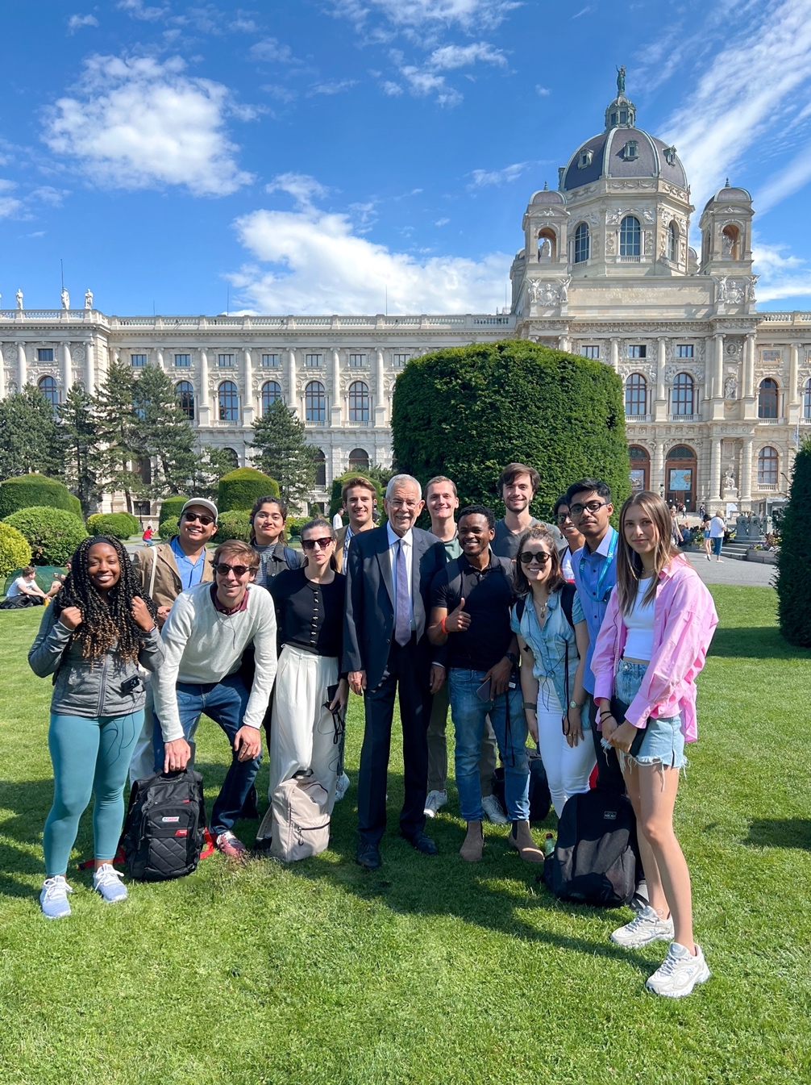

Would you like to share anything else / further statements about the ISU^{WU}?
I participated in this program about 10 years after I first studied abroad during my undergraduate years. I was a bit nervous to pick up my life for three weeks to live and study in Vienna, but the structure of the ISUWU program made it a very easy and comfortable transition to life in Vienna. I was able to expand my knowledge through my academics as well as have plenty of opportunity to experience the culture of the great city that is Vienna.

Declaration of consent: I hereby authorize WU’s International Office to use my comments and my picture for advertising and printing purposes concerning the International Summer University^{WU}.

Date and signature
July 27, 2022
Tess B. Skoller

